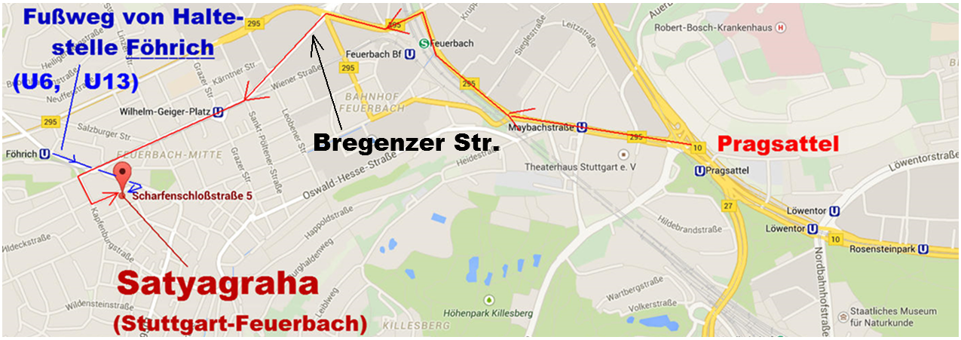

|  |  |
| --- | --- |
| **Satyagraha**  **Scharfen-**  **schloßstr. 5**  **70469**  **Stuttgart-**  **Feuerbach** |  |